**Modelling the internal states of a person**

**with Borderline Personality Disorder**

**Maria Hoțoiu, Federico Tavella**

**1 Introduction**

Borderline Personality Disorder (often referred as BPD) is a psychiatric disorder characterized by a continuous pattern of swinging moods, self-image and behavior (NIH website, 2017). People suffering from this disorder may also experience acute episodes of anger, depression and anxiety which can have different duration (typically from a few hours to days). These symptoms often leads to impulsive actions and problems in social interactions (Lis et al., 2013).

As for a relevant amount of mental disorders, people with borderline personality disorder may experience different symptoms based on disorder acuity and severity. In the case of BPD, two of the most common indicators are mood swings and display uncertainty about how they see themselves and their role in the world (NIH website, 2017).

People with borderline personality disorder also tend to view (i.e. interpret) things in a “dichromatic” way, such as all black or white. Consequently, their idea of other people can also change very quickly: an individual who is seen as a friend one day may be considered an enemy or traitor the day after. These fluctuating emotional states can lead to intense and unstable relationships. Other signs or symptoms may include:

* A pattern of intense and unstable relationships with relatives, friends, and loved ones, often swinging from extreme closeness and love (idealization) to extreme dislike or anger (devaluation);
* Feelings of dissociation (Brend et al., 2014), such as feeling cut off from oneself, seeing oneself from outside one’s body, or feelings of unreality;
* Self-harming behavior and recurring thoughts of suicidal behaviors or threats;
* Difficulty imagining embodied others (i.e. different empathy leves (Haas et al, 2015) (Dammann et al., 2011));
* Inappropriate/intense anger or problems controlling anger;
* Distorted and unstable self-image or sense of self (Dammann et al., 2011).

As previously mentioned, not all the subjects with borderline personality disorder experience every symptom. Some individuals experience only a few symptoms, while others have many. These symptoms can be triggered by everyday life events.  
 Moreover, studies show that people with borderline personality disorder can have structural and functional changes in the brain (Soloff, Paul et al., 2017) specially in the areas that control impulses and emotional regulation (NIH website, 2008). However, it is not clear whether these changes are risk factors for the disorder, or caused by the disorder.

**2 Neuropsychological background**

The findings of numerous studies and research papers from Psychiatry, Cognitive and Social Neuroscience have been used to determine the design of the computational model discussed in this paper.

The primary criteria for assessing the diagnosis of BPD according to (Hall et al.,2017), (Ellison et al., 2016), (American Psychiatric Association, 2013) are (1) behavioral dysregulation, including impulsivity, excessive and inappropriate anger, self-harming and suicidality, (2) a history of failed relationships and feelings of “emptiness” , (3) affective dysregulation including excessive mood lability, paranoia and fear of abandonment.

One explanation offered by (De Meulemeestera et al., 2016) for the interpersonal problems that these people experience is identity diffusion, fundamentally characterized by problems with self–other boundaries. According to the study, patients suffering from BPD displayed an instability in their sense of self and identity.

A factor contributing to the affective instability of BPD, according to a study by (Koenigsberg et al., 2010), is that, compared to healthy controls, patients with BPD do not engage the cognitive control regions when employing a distancing strategy to regulate emotional reactions.

Anxiety and mistrust, as well as fear of other people’s intentions are also common findings in the studies regarding BPD. One such study by (King-Casas et al., 2008) involved a mix sample of BPD patients and healthy controls playing a multi round economic exchange game. The findings suggest that BPD subjects express significantly lower levels of self-reported trust relative to healthy controls, as well as negative expectations of social partners, which was also implied by their decisions throughout the game.

When studying the link between empathy and social attributions in BPD patients, (Homan et al., 2017) found that BPD patients display the tendency to attribute behavior to traits rather than context, meaning that they have a reduced empathic capacity.

The implications of these studies to the computational model are further discussed is Section 3 and Section 4.

**3 The temporal-causal network model**

In order to conceptualize the internal processes, as well as the interaction with an external agent, of a person suffering from BPD, a temporal-causal network modelling approach was used, as described in (Treur 2016). This type of modelling can be represented at two levels: conceptual and numerical, according to (Treur 2016).

The following mechanisms based on different theories from the literatures are incorporated in the model:

* mirror neuron systems (Dapretto et al., 2006), (Iacoboni, 2008);
* control neurons with self-other distinction and control function (Iacoboni, 2008a), (Brass and Spengler, 2009);
* emotion integration (Grèzes and de Gelder, 2009), (Grèzes et al., 2009);
* regulation of enhanced sensory processing sensitivity, in particular for face expressions (Neumann et al., 2006), (Spezio et al., 2007), (Baker et al., 2008), (Corden et al., 2008);
* empathic responding using mirror neurons, self-other distinction and emotion integration (De Vignemont and Singer, 2006), (Singer and Leiberg, 2009).

In order to have an adequate social interaction, all these mechanisms should function properly. Since they are correlated to one another, the malfunction of any one of them can lead to problems in the social functioning of the individual. People who suffer from BPD display faults in some of these mechanisms, as described in Section 2. They do not express the tendency to avoid stimuli, even if they are unpleasant, therefore the avoiding mechanism presented in (Treur,2016) was excluded from the model. The manner in which these faults are translated into the model is described in Section 4.

**3.1 The conceptual representation**

Temporal-causal networks can be represented in a conceptual manner declaratively in either a graphical form or in a matrix form. The elements of a conceptual design are:

* the states of the network;
* the connections between these states;
* connection weights which characterize the different strengths of these connections;
* speed factors corresponding to each state, expressing how fast this state will change;
* combination functions corresponding to each state, indicating how the impacts from the states it is connected to will combine into a single impact on that state.

In the graphical conceptual representation, states are displayed as nodes and connections as arrow, the pointed end of the arrow indicating the direction of the impact. The connection weights can be represented by their names, the names of their values or their values next to the corresponding arrows. The graphical conceptual representation depicted in Figure 1 describes the states and their connections in a person suffering from BPD.

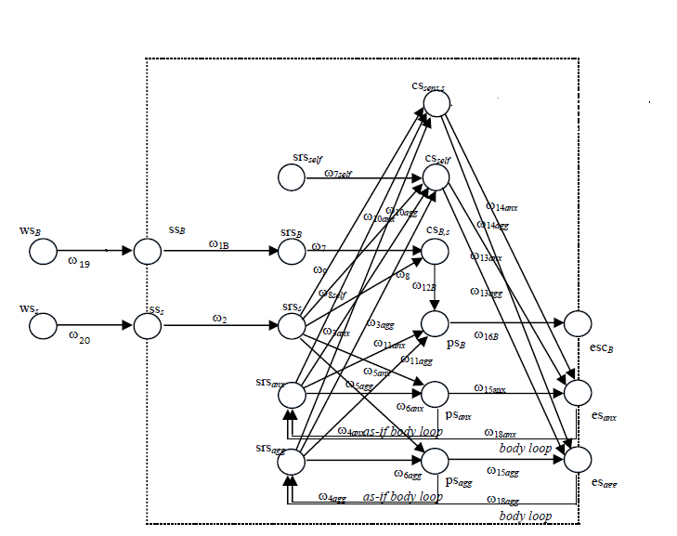

Figure 1: The graphical conceptual representation of the temporal-causal network

There are six types of states in the model: world states *ws,* which indicate an external stimulus, in this case the stimulus *s* and an agent *B;* sensor states *ss* which incorporate the sensing of these two external stimuli; sensory representation states *srs* formed based on the sensor states, but also for the agent itself and the body states of aggression and anxiety*;* preparation states *ps* for expressing the body states of anxiety and aggression, as well as for communicating to the agent B; control states *cs,* which regulate the actual expression of anxiety and aggression, as well the self-other distinction between the agent itself and the external agent B; expression states *es* for anxiety and aggression and execution of communication to the agent B state *esc*. All the states included in the model are described in Table 1.

|  |  |
| --- | --- |
| **state** | **explanation** |
| ${ws_{B}}_{}$ | world state for agent B |
| ${ws_{s}}_{}$ | world state for stimulus s |
| $ss_{B}$ | sensory state for agent B |
| ${ss_{s}}_{}$ | sensory state for stimulus s |
| ${srs_{self}}_{}$ | sensory representation state of self |
| ${srs_{B}}_{}$ | sensory representation state of B |
| ${srs_{s}}_{}$ | sensory representation state of s |
| ${srs_{anx}}_{}$ | sensory representation state of anxiety |
| ${srs_{agg}}_{}$ | sensory representation state of aggression |
| ${cs_{sens,s}}_{}$ | control state for sensing s |
| ${cs_{self}}_{}$ | control state for the agent itself |
| ${cs_{B,s}}_{}$ | control state for self-other distinction from the agent B |
| ${{ps_{B}}_{}}^{}$ | preparation state for communication with agent B |
| ${ps_{anx}}_{}$ | preparation state for anxious body state |
| ${ps_{agg}}_{}$ | preparation state for angry body state |
| ${{esc_{B}}_{}}^{}$ | execution state of communicating to B |
| ${{es}_{}}_{anx}$ | execution state of anxious response |
| ${{es}_{}}_{agg}$ | execution state of angry response |

Table 1: The states used in the model

Besides the connections described previously, there are also two loops: the *as-if body loops* between the preparation states for expressing anxiety and aggression and their sensory representation states, which adapt the internal body map, as described in (Treur, 2016). Table 2 describes all the connections between the states in the model and their strength, as well as the direction of the impact (from/to).

|  |  |  |  |
| --- | --- | --- | --- |
| **from state** | **to state** | **weight** | **explanation** |
| ${ws_{B}}_{}$ | $ss_{B}$ | ${ω_{19}}_{}$ | sensing agent B |
| ${ws_{s}}_{}$ | ${ss_{s}}_{}$ | ${ω_{20}}_{}$ | sensing stimulus s |
| ${ss_{s}}_{}$ | ${srs_{s}}_{}$ | $ω_{2}$ | representing s |
| $ss_{B}$ | ${srs_{B}}_{}$ | $ω_{1B}$ | representing B |
| ${srs_{s}}_{}$ | ${ps_{anx}}_{}$ | ${ω_{5anx}}_{}$ | responding anxiety |
| ${srs_{s}}_{}$ | ${ps_{agg}}_{}$ | ${ω_{5agg}}_{}$ | responding aggression |
| ${srs_{anx}}_{}$ | ${ps_{anx}}_{}$ | $ω_{6anx}$ | amplifying anxiety |
| ${srs_{agg}}_{}$ | ${ps_{agg}}_{}$ | $ω_{6agg}$ | amplifying aggression |
| ${srs_{anx}}_{}$ | ${ps_{B}}_{}$ | $ω_{11anx}$ | responding communication to anxiety |
| ${srs_{agg}}_{}$ | ${ps_{B}}_{}$ | $ω_{11agg}$ | responding communication to aggression |
| ${srs_{s}}_{}$ | ${cs_{B,s}}_{}$ | ${ω_{7}}_{}$ | monitoring B for self-other distinction |
| ${srs_{B}}_{}$ | ${cs_{B,s}}_{}$ | $ω_{8}$ | monitoring s for self-other distinction |
| ${srs_{s}}_{}$ | ${cs_{sens,s}}_{}$ | $ω_{9}$ | monitoring sensitivity for s |
| ${srs_{anx}}_{}$ | ${cs_{sens,s}}_{}$ | $ω_{10anx}$ | monitoring anxiety |
| ${srs_{agg}}_{}$ | ${cs_{sens,s}}_{}$ | $ω_{10agg}$ | monitoring aggression |
| ${srs_{self}}_{}$ | ${cs_{self}}_{}$ | $ω_{7self}$ | monitoring self |
| ${srs_{s}}_{}$ | ${cs_{self}}_{}$ | $ω_{8self}$ | monitoring s |
| ${srs_{anx}}_{}$ | ${cs_{self}}_{}$ | $ω_{3anx}$ | monitoring anxiety |
| ${srs_{agg}}_{}$ | ${cs_{self}}_{}$ | $ω_{3gg}$ | monitoring aggression |
| ${cs_{B,s}}_{}$ | ${ps_{B}}_{}$ | $ω_{12B}$ | controlling communication |
| ${cs_{self}}_{}$ | ${{es}_{}}_{anx}$ | $ω_{13anx}$ | controlling anxious response |
| ${cs_{self}}_{}$ | ${{es}_{}}_{agg}$ | $ω_{13agg}$ | controlling aggressive response |
| ${cs_{sens,s}}_{}$ | ${{es}_{}}_{anx}$ | $ω_{14anx}$ | suppressing anxious response |
| ${cs_{sens,s}}_{}$ | ${{es}_{}}_{agg}$ | $ω_{14agg}$ | suppressing aggressive response |
| ${ps_{anx}}_{}$ | ${{es}_{}}_{anx}$ | $ω_{15anx}$ | expressing anxious response |
| ${ps_{agg}}_{}$ | ${{es}_{}}_{agg}$ | $ω_{15agg}$ | expressing anxious response |
| ${ps_{B}}_{}$ | ${{esc_{B}}_{}}^{}$ | $ω_{16B}$ | executing communication to B |
| esanx | srsanx |  | effectuating anxiety |
| psanx | srsanx |  | predicting anxiety |
| esagg | srsagg |  | effectuating aggression |
| psagg | srsagg |  | predicting aggression |

Table 2: Connection between states and their weights

**3.2 Numerical representation**

In order to obtain a basis for further mathematical analysis of the model, the conceptual representation can be mapped into a numerical one in a systematic manner, as described in (Treur,2016). The characteristics of this type of representation are the following:

* The value of each state *Y* at each time point *t* is denoted by *Y(t)*;
* The impact of each of the connections *X1,...,Xk* towards a state *Y* at time point *t* is defined as **impact**Xi,Y(t) **=** Xi,Y Xi(t), where Xi,Y is the strength of the impact of Xi on Y;
* The total impact of the connections *X1,...,Xk* towards a state *Y* at time point *t* is defined as **aggimpact**Y(t) **=** cY(**impact**X1,Y(t),..., **impact**Xk,Y(t)), where cY is the combination function;
* The change of the state Y from the time step *t* to the next time step *t+ $Δ$ t* is represented either by the following difference equation: Y(t+ $Δ$ t) = Y(t) + Y [**aggimpact**Y(t) - Y(t)] $Δ$ t, where Y is the speed factor of the state Y; or by the following differential equation: **dY**(t)**/dt =** Y[**aggimpact**Y(t) - Y(t)].

As an example, by following the pattern described above the difference and the differential equation for psB are:

psB(t+ $Δ$ t) = psB(t) + $η_{ps_{B}}$ [cpsB(, , ) - psB(t)] $Δ$ t

**d**psB(t)/**d**t = $η_{ps_{B}}$ [$c_{ps_{B}}$ ($ω_{11anx}{srs_{agg}}_{}$, $ω_{11agg}{srs_{agg}}_{}$, $ω_{12B}{cs_{B,s}}_{}$) - psB(t)]

Each state of the model, except for the world states which have no incoming connections, gets a difference and a differential equation assigned. The interaction between these equations describe the model’s behaviour. For the model considered here there are 16 coupled difference and differential equations.

The combination functions used for all the states with only one incoming impact is is the identity function **id(...)** as described in (Treur, 2016): **cY**(V) = **id**(V) = V. By using this combination function, the difference and the differential equation for srsB, for example, are the following:

srsB(t+ $Δ$ t) = srsB(t) + $η_{srs_{B}}$ [$ω_{1B}$ ssB (t) - srsB(t)] $Δ$ t

**d**srsB(t)/**d**t = $η_{srs_{B}}$ [$ω_{1B}$ ssB (t) - srsB(t)]

For the states which have multiple incoming impacts the combination function used was the advanced logistic sum combination function **alogistic(...)**, described in (Treur,2016) as follows:

**cY**(V1,...,Vk) = **alogistic**(V1,...,Vk) = (-)(1+)

The parameters $τ$ and $σ$ of the alogistic function represent the threshold and the steepness. This function has the property that it maps 0 values to 0 and it also keeps the values between 0 and 1. With this combination function, the following difference and differential equations for psB, for example, are obtained:

psB(t+ $Δ$ t) = psB(t) + $η_{ps_{B}}$ [**alogistic $σ,τ$**($ω_{11anx}srs_{anx}$, $ω_{11agg}{srs_{agg}}_{}$, $ω_{12B}{cs_{B,s}}_{}$) - psB(t)] $Δ$ t

**d**psB(t)/**d**t = $η_{ps_{B}}$ [**alogistic $σ,τ$**($ω_{11anx}{srs_{agg}}_{}$, $ω_{11agg}{srs_{agg}}_{}$, $ω_{12B}{cs_{B,s}}_{}$) - psB(t)]

**4 Simulation results**

The numerical representation presented above was implemented in Matlab, in order to obtain a realistic picture of how the mechanisms discussed in Section 3 interact in the case of a person suffering from BPD. The traits presented in Section 2 are translated into the model by constraints of some of the parameters, as shown in Table 3. Following the reasoning presented in (Treur, 2016) a reduced self-other distinction means that the connections between srss and csB,s and srsB and csB,s are weak, therefore the values of $ω_{7}$, $ω_{8}$ are low. The intensity of the anger and of the anxiety experienced by these people implicates that the connections between their corresponding sensory representations srsanx and srsagg and the control state for sensing cssens,s are weak, as well as the connections between the control state for monitoring csself and srsanx and srsagg with $ω_{10anx}$, $ω_{10agg},$  $ω_{3agg}$ and $ω_{3anx}$ low. The connection between the sensory representation of a stimulus s srss and the control state for sensing cssens,s  is also weak, with $ω_{9}$ low, since people suffering from BPD do not exhibit a distancing behaviour. The poor monitoring of emotions translates into weak connections between the sensory representations of the agent itself srsself, as well as the sensory representation of stimulus s srss, and the control state for the agent itself csself with $ω_{7self }$ and $ω_{8self}$ low. Reduced self-control implicates that the connections coming from the control state cssens,s, as well as from csself, to the expression states esanx and esagg are weak, so $ω_{13anx}$, $ω_{13agg}$, $ω_{14anx}$ and $ω_{14agg}$ are low. All the weights of the connections except for those in Table 3 are 1.

|  |  |  |  |
| --- | --- | --- | --- |
| **Connection** | **Value** | **Connection** | **Value** |
| $ω_{7}$ | 0.5 | $ω_{13anx}$ $ω_{13agg}$ | -0.2 |
| $ω_{8}$ | 0.5 | $ω_{7self }$ $ω_{8self}$ | 0.2 |
| $ω_{3agg}$ $ω_{3anx}$ | 0.2 | $ω_{14anx}$ $ω_{14agg}$ | -0.2 |
| $ω_{10anx}$ $ω_{10agg}$ | 0.2 | $ω_{9}$ | 0.2 |

Table 3: Weights and their values

In order to incorporate the impulsivity trait in the implementation, the speed factors of the control states cssens,s, csself and csB,s is adjusted as being lower than for the other states, for which it is 1. The speed factor of the states regarding communication, psB and escB are also a little lower than one, since verbalizing is a little difficult for people who suffer from BPD so it is most likely to happen after the body expressions of anxiety and aggression. The parameters for the advanced logistic sum combination function corresponding to each state are shown in Table 4.

|  |  |  |  |  |  |
| --- | --- | --- | --- | --- | --- |
| **state** | $σ$ | $τ$ | **state** | $σ$ | $τ$ |
| cssens,s | 1 | 0.2 | srsanx | 5 | 0.4 |
| psB | 4 | 0.2 | psanx | 5 | 0.4 |
| csB,s | 2 | 0.2 | esanx | 5 | 0.4 |
| srsagg | 5 | 0.4 | psagg | 5 | 0.4 |
| esagg | 5 | 0.4 | csself | 1 | 0.2 |

Table 4: Parameters for the combination function alogistic $σ,τ$ for each state

The step size is $Δ$ t = 0.5. The initial values of the states are 0, except for the input states wsB and wss which have either the value of 0.2 or 0, equivalent to no stimulus. The value of 0.2 is chosen so low in order to illustrate the strong impact a weak stimulus has on a person suffering from BPD. The results of the simulation for the values discussed above are shown in Figure 2.

In the first part of the simulation, all the values go up, first the values of the stimuli related states, ssB and sss which are equal, so their graphical representations are overlapping, making only ssB visible. The same is happening with srsB and srsS . Even though the value of the input is as low as 0.2, the values of the states for preparation psanx and psagg and expression esanx and esagg climb really fast to values as high as 0.8 and 0.9. This illustrates the power of a small stimuli, when self-control is not working correctly. Note that, since aggression and anxiety are expected to play an equal role in this model, their graphical representations are overlapping. The control states for emotion regulation and suppression and self-other distinction cssens,s, csB,s and csself are always low, as expected. The preparation psB communication to agent B escB happen after the expressions of anxiety and aggression, corresponding to the behavior previously described.

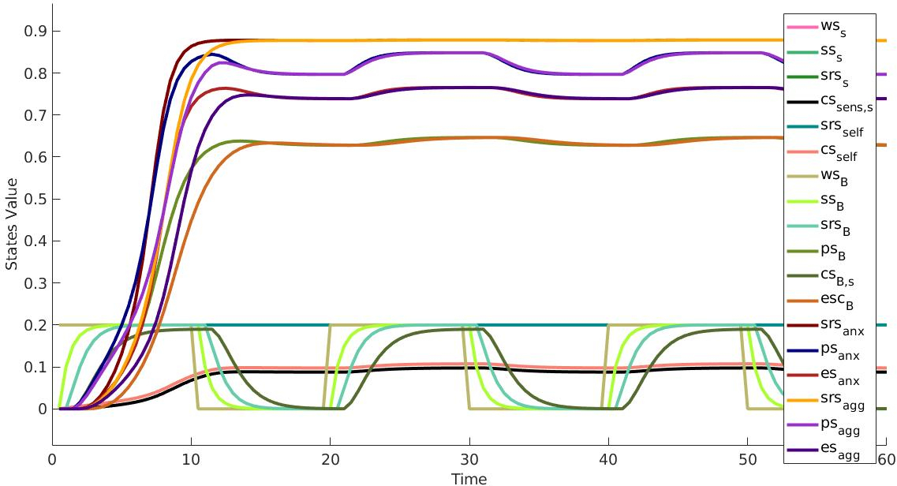

Figure 2: Results of the simulation

After the first 10 time steps, the stimuli go away, meaning that the values of wss and wsB become 0. In a normal person, this would imply that the values of all the other states should decrease to 0, but here the states related to anger and anxiety drop only very little , as expected. The sensory representation states for anxiety srsanx and aggression srsagg are always high in value, illustrating the constantly disturbed inner state people suffering from BPD experience. Since the value of the sensory representation state is high and the values of the control states are low, the expression of the feelings is also high, even if there are no stimuli present. This process of stimuli/no stimuli is repeated throughout the simulation a few times, with the same results.

**5 Verification by Mathematical Analysis**

In order to verify the implementation of the model, a mathematical analysis of the equilibria was performed. A model is in equilibrium at a time point t if all the states of the model have a stationary point at that time t. A state Y has a stationary point at a time t if $Y(Δt+t)=Y(t)$, for a small $Δt$. By considering the differential equation representation for a temporal-causal network model in general, a state Y has a stationary point a time t if:

Y(t) = **cY**(X1,Y(t)X1(t),..., Xk,Y(t)Xk(t))

where cY is the combination function for the state Y and X1,...,Xk are the states which have an impact on Y. Following this representation if we consider the equilibrium equations for all the states Xi of the model, by leaving out the t and denoting the values as constants Xi, we get that an equilibrium is a solution (X1,...,Xn) of the following n equations:

**X1** = **cX1**(X1,X1**X1**,...,Xn,X1**Xn**)

...

**Xn** = **cXn**(X1,Xn**X1**,...,Xn,Xn**Xn**)

The model discussed here has 18 states, out of which two are world states, therefore 16 equilibrium equations. For example, the equilibrium equation for the state ssB, which has the identity combination function, is:

ssB = wsB

For the other states which use the identity combination function, the equilibrium equations are similar. For the states which use the combination function alogistic, the equilibrium equations are similar to this one, which is for the state psB:

psB =  **alogistic $σ,τ$**($ω_{11anx}$ srsanx,srsagg,csB,s)

Due to the 10 equations that include a logistic function, the equilibrium equations system can not be solved analytically in an explicit manner, but they can be used for the verification of the model. Since the model discussed here has an alternating presence of the stimuli, the model reaches equilibrium several times.

In order to be able to analyse the equilibrium points of the model, the number of time steps for observation was increased from 120 to 1200, so that the values of the states would be observed more often. The stimuli is removed and added again once every 200 time steps, so we would expect that the model reaches equilibrium 6 times in the simulation. This type of pattern is called a limit cycle, with state values changing all the time. In a limit cycle, each state fluctuates between a minimum and a maximum value. When it reaches the time points for either a minimum or a maximum, each state should have a stationary point, which means that the equation for a stationary point should be verified. The stationary point equations were fulfilled for all the states of the model, with an accuracy very much below 10-2, as can be seen in Table 5 which is evidence that the implemented model does what it is expected.

|  |  |  |  |  |  |  |  |
| --- | --- | --- | --- | --- | --- | --- | --- |
| **state** | **ssB** | **srsB** | **sss** | **srss** | **srsanx** | **srsagg** | **csself** |
| **Maxima** |  |  |  |  |  |  |  |
| **Time point** | 196 | 196 | 196 | 196 | 196 | 196 | 196 |
| **Value** | 0.2 | 0.2 | 0.2 | 0.2 | 0.878487 | 0.878487 | 0.107426 |
| **Aggimpact** | 0.2 | 0.2 | 0.2 | 0.2 | 0.878487 | 0.878487 | 0.107426 |
| **Deviation** | 0 | 0 | 0 | 0 | 0 | 0 | 0 |
| **Minima** |  |  |  |  |  |  |  |
| **Time point** | 406 | 406 | 406 | 406 | 406 | 406 | 406 |
| **Value** | 9.96e-61 | 1.97e-58 | 9.96e-61 | 1.97e-58 | 0.877405 | 0.877405 | 0.087503 |
| **Aggimpact** | 0 | 0 | 0 | 0 | 0.877405 | 0.877405 | 0.087503 |
| **Deviation** | 9.96e-61 | 1.97e-58 | 9.96e-61 | 1.97e-58 | 0 | 0 | 0 |

|  |  |  |  |  |  |  |  |  |
| --- | --- | --- | --- | --- | --- | --- | --- | --- |
| **state** | **csB,s** | **cssens,s** | **psB** | **psagg** | **psanx** | **esanx** | **esagg** | **escB** |
| **Maxima** |  |  |  |  |  |  |  |  |
| **Time point** | 196 | 196 | 196 | 196 | 196 | 196 | 196 | 196 |
| **Value** | 0.189974 | 0.097537 | 0.688646 | 0.848264 | 0.848264 | 0.848264 | 0.848264 | 0.646615 |
| **Aggimpact** | 0.189974 | 0.097537 | 0.688646 | 0.848264 | 0.848264 | 0.848264 | 0.848264 | 0.646615 |
| **Deviation** | 0 | 0 | 0 | 0 | 0 | 0 | 0 | 0 |
| **Minima** |  |  |  |  |  |  |  |  |
| **Time point** | 406 | 406 | 406 | 406 | 406 | 406 | 406 | 406 |
| **Value** | 2.77e-37 | 0.087503 | 0.627566 | 0.796629 | 0.796629 | 0.739934 | 0.739934 | 0.627566 |
| **Aggimpact** | 0 | 0.087503 | 0.627566 | 0.796629 | 0.796629 | 0.739934 | 0.739934 | 0.627566 |
| **Deviation** | 2.77e-37 | 0 | 0 | 0 | 0 | 0 | 0 | 0 |

Table 5: Overview of the outcomes of the calculation of the stationary points

**6 Parameter tuning**

In order to tune the parameters (i.e. speed factor), we used the simulated annealing algorithm, taking as goodness metric the SSR. We considered a time interval equal to [0,30] with a step of 1, as illustrated in Figure 3.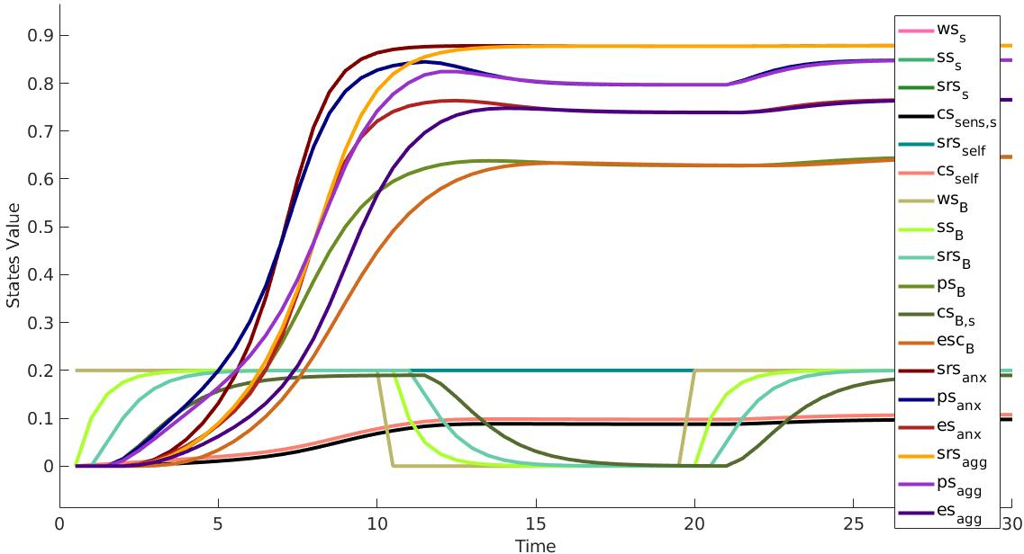

Figure 3: simulation with maxT = 30 and $Δt = 1$

Pseudo-empirical data were generated manually due to lack of empirical data. For each of the 18 states, we generated 30 values (one for each second). All the different speed factors can vary in the range [0,1]. Table 6 provide all the different values for the speed factor. On the other hand, in Figure 4 we can see how the values of the different model states are changing with these new speed factors, compared to the empirical data. The final SSR for the values given in Table 6 is 1.6161 and, thus the final error, calculates as square root of $\sqrt{SSR/(n*m)}$ where *n* is the number of states and *m* the number of point for each state, is 0.0547.

|  |  |  |  |  |  |  |  |  |
| --- | --- | --- | --- | --- | --- | --- | --- | --- |
| $η_{ws_{s}}$ | $η_{ss_{s}}$ | $η_{srs_{s}}$ | $η_{cs_{sens,self}}$ | $η_{srs_{self}}$ | $η_{cs_{self}}$ | $η_{ws_{B}}$ | $η_{ss_{B}}$ | $η_{srs_{B}}$ |
| 0 | 0.982 | 0.967 | 0.593 | 0 | 0.998 | 0 | 0.294 | 0.652 |

|  |  |  |  |  |  |  |  |  |
| --- | --- | --- | --- | --- | --- | --- | --- | --- |
|  |  |  |  |  |  |  |  |  |
| 0.724 | 0.500 | 0.592 | 0.850 | 0.983 | 0.910 | 0.999 | 0.894 | 0.898 |

Table 6: speed factor from the parameter tuning

Figure 4: simulation using speed factors from the tuning and comparison with empirical data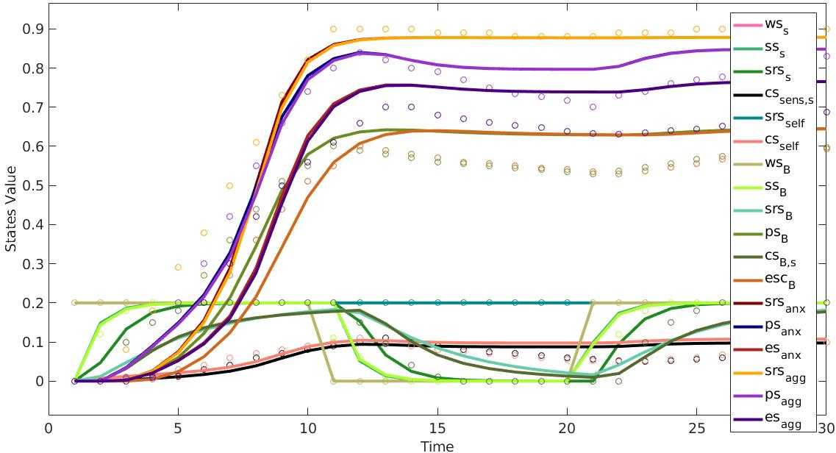

**7 Discussion**

In this paper a computational model of the internal states of people suffering from Borderline Personality Disorder was presented. First, a conceptual model was built based on the design of a temporal-causal network modelling approach presented in (Treur,2016), incorporating the characteristics described by neuropsychological findings from the literature such as identity diffusion, the absence of a distancing mechanism, impulsivity, reduced emotion control and poor monitoring, low empathic capacity.

The characteristics described above were incorporated in the model by adding specific values to the parameters concerning these mechanisms, such as connection weights and speed factors. These parameters were verified by mathematical analysis, with satisfying results. A tuning of the parameters was also conducted, using pseudo-empirical data, since no empirical data was available.

**References:**

[1] <https://www.nimh.nih.gov/health/topics/borderline-personality-disorder/index.shtml>

[2] *American Psychiatric Association, Diagnostic and Statistical Manual of Mental Disorders*. Fifth edition

[3] Celine De Meulemeestera, Benedicte Lowyckb, Rudi Vermoteb, Yannic Verhaestc, Patrick Luytena. *Mentalizing and interpersonal problems in borderline personality disorder: The mediating role of identity diffusion.* Psychiatry Research 258. 2017.

[4] Philipp Homan, Marianne C. Reddan, Tobias Brosch,Harold W. Koenigsberg, Daniela Schiller*. Aberrant link between empathy and social attribution style in borderline personality disorder.* Journal of psychiatric research 94. 2017.

[5] Jan Treur. *Network-Oriented Modeling: Addressing Complexity of Cognitive, Affective and Social Interactions.* Springer. 2016.

[6] M. Iacoboni, Mirroring People: The New Science of How We Connect with Others. Farrar, Straus & Giroux. 2008.

[7] M. Iacoboni, M. Dapretto. *The mirror neuron system and the consequences of its dysfunction*. Nat. Rev. Neurosci. 7, 942–951. 2006.

[8] M. Brass, S. Spengler. *The inhibition of imitative behaviour and attribution of mental states, in Social Cognition: Development, Neuroscience, and Autism*. Ed. by T. Striano, V. Reid. Wiley-Blackwell. 2009. pp 52–66

[9] J. Grèzes, B. de Gelder. *Social perception: understanding other people’s intentions and emotions through their actions, in Social Cognition: Development, Neuroscience, and Autism*. Ed. by T. Striano, V. Reid. Wiley-Blackwell. 2009. pp. 67–78

[10] J. Grèzes, B. Wicker, S. Berthoz, B. de Gelder. *A failure to grasp the affective meaning of actions in autism spectrum disorder subjects*. Neuropsychologica 47(1816–1825). 2009.

[11] D. Neumann, M.L. Spezio, J. Piven, R. Adolphs*. Looking you in the mouth: abnormal gaze in autism resulting from impaired top-down modulation of visual attention*. Soc. Cognit. Affect.Neurosci. 1(194–202). 2006.

[12] M.L. Spezio, R. Adolphs, R.S.E. Hurley, J. Piven. *Analysis of face gaze in autism using ‘Bubbles’*. Neuropsychologia 45(144–151). 2007.

[13] A.E.Z. Baker, A.E. Lane, M.T. Angley, R.L. Young. *The relationship between sensory processing patterns and behavioural responsiveness in autistic disorder: a pilot study*. J. Autism Dev. Disord. 38(867–875). 2008.

[14] B. Corden, R. Chilvers, D. Skuse. *Avoidance of emotionally arousing stimuli predicts social-perceptual impairment in Asperger's syndrome*. Neuropsychologia 46(137–147). 2008.

[15] F. De Vignemont, T. Singer. *The empathic brain: how, when and why?* Trends Cogn. Sci. 10(437–443). 2006.

[16] T. Singer, S. Leiberg. *Sharing the emotions of others: the neural bases of empathy*. The Cognitive Neurosciences, 4th ed., ed. by M.S. Gazzaniga (MIT Press, 2009), pp. 973–986. 2009

[17] Mellisa A. Hall, Katherine M. Riedford. *Borderline Personality Disorder: Diagnosis and Common Comorbidities.* The Journal for Nurse Practitioners - JNP. Volume 13, Issue 9, October 2017. 2017.

[18] Ellison WD, Rosenstein L, Chelminskil I, Dalrymple K, Zimmerman M. *The clinical significance of single features of borderline personality disorder; anger, affective instability, impulsivity, and chronic emptiness in psychiatric outpatients*. J Pers Disord. 2016;

[19] American Psychiatric Association. *Diagnostic and Statistical Manual of Mental Disorders*. 5th ed. Arlington, VA: American Psychiatric Association; 2013.

[20] Harold W. Koenigsberg, Jin Fan, Kevin Ochsner, Xun Liu, Kevin G. Guise, Scott Pizzarello, Christine Dorantes, Stephanie Guerreri, Lucia Tecuta, Marianne Goodman, Antonia New, Larry J Siever. *Neural correlates of the use of psychological distancing to regulate responses to negative social cues: a study of patients with borderline personality disorder.* Biol Psychiatry. 2010.

[21] King-Casas B, Sharp C, Lomax-Bream L, Lohrenz T, Fonagy P, Montague PR. *The rupture and repair of cooperation in borderline personality disorder*. Science. 2008.

[22] Brand, Bethany L. and Lanius, Ruth A. *Chronic complex dissociative disorders and borderline personality disorder: disorders of emotion dysregulation?* Borderline Personality Disorder and Emotion Dysregulation, Oct 2014, vol 1.

[23] Haas, B. W., & Miller, J. D. (2015). *Borderline personality traits and brain activity during emotional perspective taking.* Personality Disorders: Theory, Research, and Treatment, 6(4), 315-320.

[24] G. Dammann et al. *The Self-Image in Borderline Personality Disorder: An in-Depth Qualitative Research Study*. Journal of Personality Disorders 2011 25, 4, 517-527

[25] Homan, Philipp et al. *Aberrant link between empathy and social attribution style in borderline personality disorder.* Journal of Psychiatric Research , Volume 94 , 163 - 171. Nov 2017.

[26]<https://www.nimh.nih.gov/news/science-news/2008/emotion-regulating-circuit-weakened-in-borderline-personality-disorder.shtml>

[27] Soloff, Paul et al. “Structural Brain Abnormalities in Borderline Personality Disorder: A Voxel-Based Morphometry Study.” Psychiatry Research 164.3 (2008): 223–236. PMC. Web. 16 Dec. 2017.

[28] Lis, S. & Bohus, M. Curr Psychiatry Rep (2013) 15: 338. https://doi.org/10.1007/s11920-012-0338-z

Psychotherapy is the first-line treatment for people with borderline personality disorder. A therapist can provide one-on-one treatment between the therapist and patient, or treatment in a group setting. Therapist-led group sessions may help teach people with borderline personality disorder how to interact with others and how to effectively express themselves.

Two examples of psychotherapies used to treat borderline personality disorder include:

* **Dialectical Behavior Therapy (DBT):** This type of therapy was developed for individuals with borderline personality disorder. DBT uses concepts of mindfulness and acceptance or being aware of and attentive to the current situation and emotional state. DBT also teaches skills that can help:
  + Control intense emotions
  + Reduce self-destructive behaviors
  + Improve relationships
* **Cognitive Behavioral Therapy (CBT):** This type of therapy can help people with borderline personality disorder identify and change core beliefs and behaviors that underlie inaccurate perceptions of themselves and others, and problems interacting with others. CBT may help reduce a range of mood and anxiety symptoms and reduce the number of suicidal or self-harming behaviors.

Because the benefits are unclear, medications are not typically used as the primary treatment for borderline personality disorder. However, in some cases, a psychiatrist may recommend medications to treat specific symptoms such as:

* **mood swings**
* depression
* other co-occurring mental disorders